MAT 125: DISCRETE MATHEMATICS II LECTURE NOTES
THE CONDITIONAL AND BI-CONDITIONAL
By Dr. Runji Flora

SUMMARY OF LOGICAL EQUIVALENCES
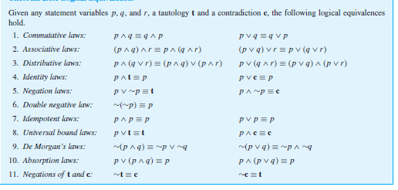
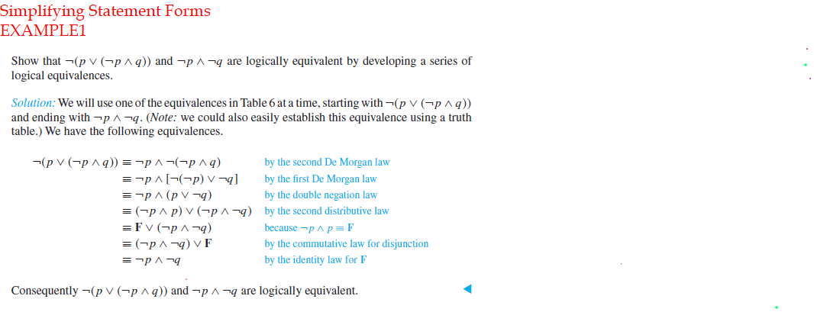

EXAMPLE 2
Use logical equivalences to show that

Solution
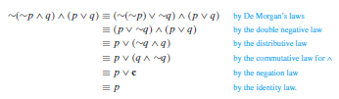

CONDITIONAL STATEMENTS
Definition:
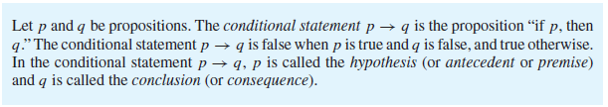

Remark:

The Truth Table for the Conditional statement p → q.

The statement p → q is true when both p and q are true and when p is false (no matter what truth value q has).

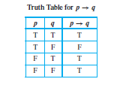
Remark:
A conditional statement that is true by virtue of the fact that its hypothesis is false is often called vacuously true or true by default.

Example: The statement “If you show up for work Monday morning, then you will get the job” is vacuously true if you do not show up for work Monday morning.

In general, when the “if” part of an if-then statement is false, the statement as a whole is said to be true, regardless of whether the conclusion is true or
false.

Order of operations
In expressions that include → as well as other logical operators such as ∧, ∨, and ∼, the order of operations is that → is performed last. Thus, according to the specification of order of operations, ∼ is performed first, then ∧ and ∨, and finally→.

Other terminologies that express conditional statements
The following are different terminologies that are commonly used in place of " if p then q"
“p implies q”
“if p, q”
“p only if q
“p is sufficient for q”
“a sufficient condition for q is p”
“q if p”
“q whenever p”
“q when p”
“q is necessary for p”
“a necessary condition for p is q”
“q follows from p”
“q unless ¬p”

Representation of Conditional as Disjunction
The conditional “if p then q” is logically equivalent to “not p or q”
That is: p →q ≡ ∼p ∨ q. (verify this with a truth table)

Example: Rewrite the following statements without using the conditional:
(a) If it is cold, he wears a hat.
(b) If productivity increases, then wages rise.

Recall that “If p then q” is equivalent to
“Not p or q;” that is, p → q ≡ ¬p ∨ q.
Hence, we have
(a) It is not cold or he wears a hat.
(b) Productivity does not increase or wages rise.

The Negation of a Conditional Statement
The negation of "If p then q" is logically equivalent to "p and not q."

Example
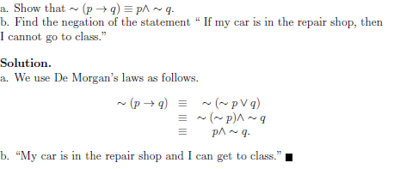

The Contrapositive of a Conditional Statement

Definition: The contrapositive of a conditional statement of the form “If p then q” is "If ∼q then ∼p".

Symbolically, The contrapositive of p →q is ∼q →∼p.

A conditional statement is logically equivalent to its contrapositive.(Verify)

The Converse and inverse of a Conditional Statement

Definition: Suppose a conditional statement of the form “If p then q” is given:

The converse is “If q then p.”
The inverse is “If ∼p then ∼q.”

Symbolically,

The converse of p →q is q → p, and
The inverse of p →q is ∼p →∼q.

Remark:

- A conditional statement and its converse are not logically equivalent.(Verify)

  - A conditional statement and its inverse are not logically equivalent.(Verify)
  - The converse and the inverse of a conditional statement are logically equivalent to each other.(Verify)

EXAMPLE
What are the contrapositive, the converse, and the inverse of the conditional statement: “The home team wins whenever it is raining?”

Solution:
Because “q whenever p” is one of the ways to express the conditional statement p → q, the original statement can be rewritten as

“If it is raining, then the home team wins.”

Consequently, the contrapositive of this conditional statement is
“If the home team does not win, then it is not raining.”

The converse is
“If the home team wins, then it is raining.”

The inverse is
“If it is not raining, then the home team does not win.”

The biconditional statement

DEFINITION
Let p and q be propositions.
The biconditional statement denoted p ↔ q is the proposition “p if and only if q.”

The biconditional statement p ↔ q is true when p and q have the same truth
values, and is false otherwise.

Biconditional statements are also called bi-implications.

There are some other common ways to express p ↔ q: These include:
“p is necessary and sufficient for q”
“if p then q, and conversely”
“p iff q.”

Truth table for the biconditional statement
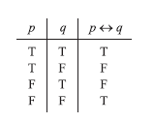

In order of operations ↔ is coequal with→. As with ∧ and ∨, the only way to indicate precedence between them is to use parentheses.

Example:
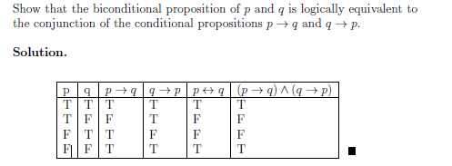

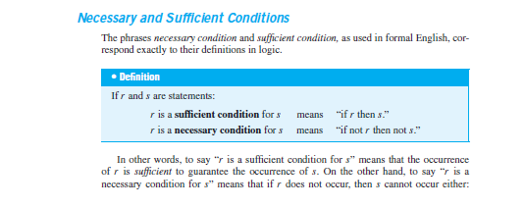

Converting a Sufficient Condition to If-Then Form

Example:
Rewrite the following statement in the form “If A then B”:

Pia’s birth on Kenyan soil is a sufficient condition for her to be a Kenyan citizen.

Solution: If Pia was born on Kenyan soil, then she is a Kenyan citizen.

Converting a Necessary Condition to If-Then Form

Example:
Use the contrapositive to rewrite the following statement in two ways:

George’s attaining age 35 is a necessary condition for his being president of the United States.

Solution
Version 1: If George has not attained the age of 35, then he cannot be president of the United States.

Version 2: If George can be president of the United States, then he has attained the age of 35.

Exercise:
Prove that the negation of the biconditional “𝑝 if and only if 𝑞” (~(𝑝↔𝑞)) is equivalent to the exclusive disjunctive form “Either 𝑝 or 𝑞, but not both” (𝑝⊕𝑞).

